CURRICULAM VITAE

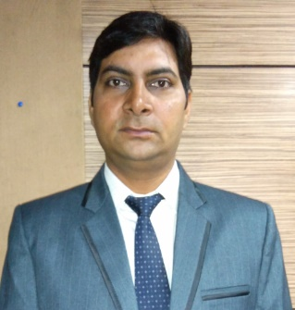
ARUN KUMAR SAGAR

P-54, VIJAY VIHAR, UTTAM NAGAR,
NEW DELHI-110059
Mobile: 9971701449
E-mail: arun_sagar79@yahoo.co.in

Objective:

I am a young energetic man having a great enthusiasm and stamina to strive willingly to accomplish the organizational objectives, if provided a chance with your establishment. I assure you, I will be disciplined, hardworking, faithful and sincere to your company.

Professional Experience:

Indian Culinary Forum Executive Secretary (Oct 16- Till Date)
Key responsibilities:
Office administration includes of Tele Calling for the Lifetime Membership, Corporate Membership & Sponsorships.
Arranging venues for the meetings on monthly and on urgent basis.
Take minutes during the meeting and circulate to concern by Emails and make filling for future purposes.
Coordinating during Events like Chefs Awards, Competitions for Chefs at Aahar every year & making arrangement for family get together.
Arranging advertisement for the quarterly issue of our magazine and arranging articles for the magazine.
Making P&L reports & coordinating with C.A.

CLASSIC HOTELS GROUP OF HOTELS Asst. Sales Manager (Jan16- Sep16)
Key responsibilities: Travel agency and Corporate sales
Pachar Group of Hotel Asst. Sales Manager (March14- Dec15)
Key responsibilities: Inbound Travel agency and Corporate sales
The Capitol, Bangalore ASM (Feb12-Feb14)
Key responsibilities: Corporate sales from Delhi RSO
CLASSIC HOTELS GROUP OF HOTELS Executive sales (Feb11-12)
Key responsibilities: Rooms division sales.
Indian Heritage & Resorts Sales Executive (2008-2010)
Key responsibilities: Inbound Travel Agency

Industrial Training:

- Vocational training in House Keeping and Front Office Department in Ashok Group of Hotels (ITDC) from 21-12-01 to 06-01-02.
- Six-month industrial training in House Keeping and Front Office Department in Radisson Hotel from 12-06-02 to 10-12-02.

Technical Qualification:

- Computer Course from G. S. Graphics (MS-Office) in 2001.
- One year Diploma in English Shorthand & Typing in 1997-98.

Educational Qualification:

- PG Diploma in Journalism & Mass Communication from Madurai Kama Raj University (2008)
- PG Diploma in Accommodation Operation & Management from I.H.M. Pusa Institute, New Delhi in (2002)
- Basic Course in Travel Agency & Tour Operation, I.I.T.T.M (Delhi Chapter) (2006)
- Graduation (B.A Pass) From Delhi University (1999)
- 12th Pass from C.B.S.E. (1996)
- 10th Pass from C.B.S.E. (1994)

Personal Information:

Fathers Name : Sh. K.S. Sagar
Date of Birth : 28th April 1979.
Nationality : Indian
Marital Status : Married
Interest : Listening Music, Traveling, Cooking.
Strengths : Hardworking, Enthusiastic, Disciplined & Innovative.

Salary : 3.84 Lakh per annum.
Expected : Negotiable

Date:
Place: New Delhi

